Lab - Investigate BIOS or UEFI Settings

Introduction
In this lab, you will boot the computer, explore the firmware setup utility program, and change the boot order sequence.

Recommended Equipment
- Computer with or without operating system
- Motherboard manual

Instructions

Enter BIOS or UEFI.

Power on the computer.
      - Plug the power supply cable into an AC wall outlet.
      - If there is a power switch on the power supply, set the switch to “1” or “on”.
      - Turn on the computer with the power button on the front panel.
Note: If the computer beeps more than once, or if the power does not come on, notify your instructor.

Enter the firmware setup program.
During POST, press the firmware setup key or key combination. The firmware setup utility program screen will appear.

Questions:
What is the key or combination of keys used to enter the firmware setup utility program?
F1
Who manufactures the BIOS or UEFI system for your computer?
Lenovo
What is the BIOS or UEFI version?
N20ET08W (0.08)

Explore the Settings.

List the main menu options.

Question:
List the main menu options and describe what is monitored in each menu?

Main | Displays system information such as the BIOS version, BIOS date, CPU type and speed, installed memory (RAM), serial numbers, UUID, MAC address, and Secure Boot status.
Config | Configures hardware settings, including CPU, USB, display, storage (SATA), network, power management, and other onboard devices.
Date/Time | Displays and allows you to set the system date and time.
Security | Manages security settings such as passwords, Secure Boot, TPM (Security Chip), and other security features.
Startup | Displays and configures the boot order, boot mode, and startup options.
Restart | Allows you to save or discard changes, load default settings, and restart or exit the BIOS setup.

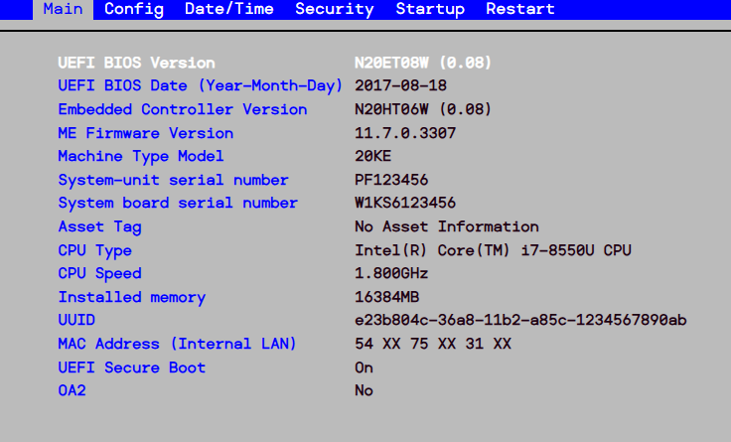

Find the security settings.
Navigate through each screen to find the security settings.

Question:
What security settings and features are available?
-Password
-Fingerprint
-Security Chip
-UEFI BIOS Update Option
-Memory Protection
-Virtualization
-I/O Port Access
-Internal Device Access
-Anti-Theft
-Secure Boot
-Intel(R) SGX
-Device Guard
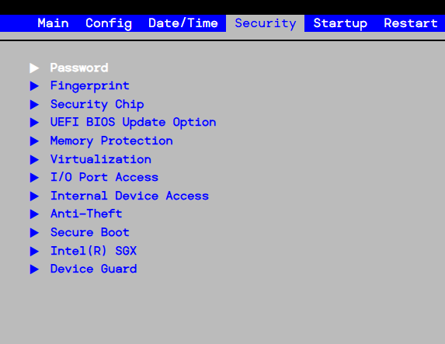

Find the CPU settings.
Navigate through each screen to find the CPU settings.

Questions:
What is the CPU speed?
1.800Ghz
What other information is listed for the CPU?
CPU Type: Intel(R) Core(TM) i7-8550U CPU

Find the RAM settings.
Navigate through each screen to find the RAM settings.

Questions:
What is the RAM speed?
Not displayed in the Lenovo BIOS Simulator.
What other information is listed for the RAM?
Installed memory: 16384 MB (16 GB)

Find the hard drive settings.
Navigate through each screen to find the hard drive settings.

Questions:
What information is listed for the hard drive?
The BIOS displays the storage device model (NVMe0 SAMSUNG MZVLB512HAJQ-000L7) and other available boot storage devices such as ATA HDD0 and USB HDD.
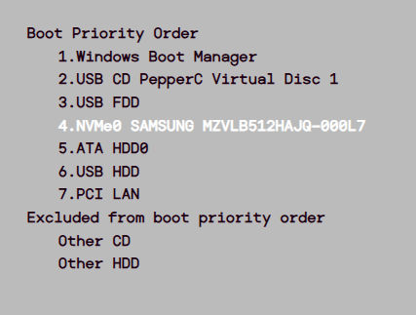

Find the boot order sequence.
Navigate through each screen to find the boot order sequence.

Questions:
What is the first boot device in the boot order sequence?
Windows Boot Manager
How many additional devices can be assigned in the boot order sequence?
- Windows Boot Manager (First Boot Device)
- USB CD PepperC Virtual Disc 1
- USB FDD
- NVMe0 SAMSUNG MZVLB512HAJQ-000L7
- ATA HDD0
- USB HDD
- PCI LAN

Set the device boot order settings.
      - Ensure that the first boot order device is the optical drive.
      - Ensure that the second boot order device is the hard disk drive.

Questions:
Why would you change the first boot device to the optical drive?
To allow the computer to boot from a CD/DVD first when installing or repairing an operating system.
What happens when the computer boots and the optical drive does not contain bootable media?
The computer skips the optical drive and automatically boots from the next device in the boot order, such as the hard drive or SSD.

Find the power management setup or ACPI screen.
Navigate through each screen to find the power management setup screen, or ACPI screen.

Question:
What power management settings are available?
The available power management settings are Intel(R) SpeedStep Technology, Mode for AC, Mode for Battery, Adaptive Thermal Management, CPU Power Management, Power On with AC Attach, and Disable Built-in Battery.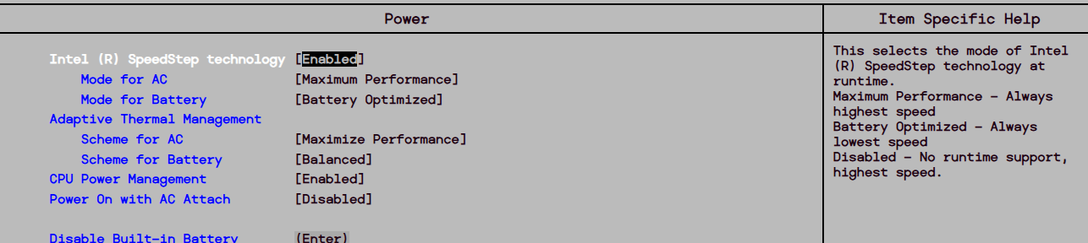

Find the PnP settings.
Navigate through each screen to find the PnP settings.

Question:
What PnP settings are available?
There is no separate Plug and Play (PnP) menu in the Lenovo ThinkPad X280 BIOS. The BIOS automatically detects hardware devices. The Config menu includes network-related settings such as Wake On LAN, UEFI IPv4/IPv6 Network Stack, PXE Boot Priority, and MAC Address Pass Through.
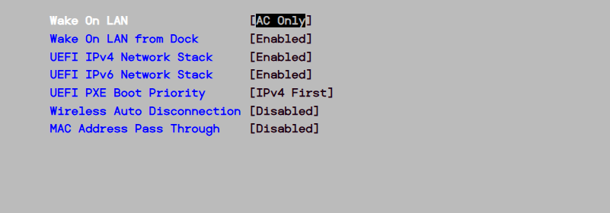

Find the splash screen settings.
Navigate through each screen to find the splash screen settings.

Question:
What splash screen settings are available?
No dedicated splash screen settings are available in the Lenovo ThinkPad X280 BIOS simulator. The Startup menu only provides boot-related settings such as Boot Mode, Option Key Display, Boot Device List F12 Option, and Boot Order Lock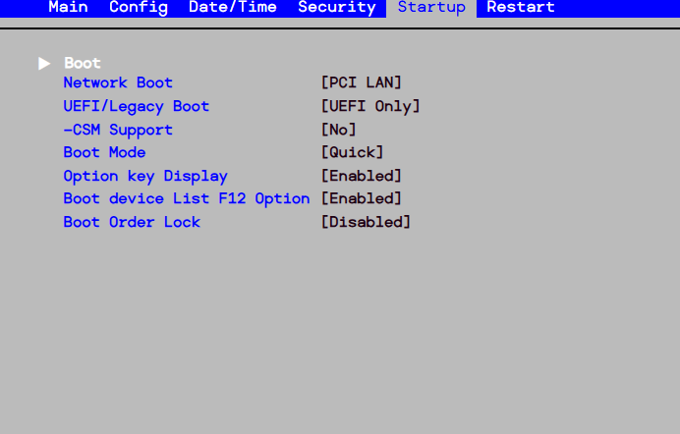

Save and exit the setup utility program.
Save the new BIOS/UEFI settings and exit the setup utility program. The computer should restart automatically.
Note: An error message stating that an OS cannot be found (or a similar error) will appear on the screen after the computer boots. An operating system must now be installed to prevent this error. It is safe to turn off the computer at this time.
This lab is complete. Please have the instructor verify your work.
End of Document

